Contact Information
For AV support:
In Case of an AV Emergency Call: 607-255-0778
Email: Eng. Classtech Support engrclasstech@cornell.edu
AV Support Availability: Monday thru Friday, 8:00am to 5:00pm

For Facilities assistance:
Thom Quinn tlq3@cornell.edu 607-255-3540

For Emergencies Dial: 911 (CU Police) 255-1111

Room Equipment
Projector Projector Screen HDMI/USB Cable Connection Assisted Listening Microphones Podium (Height Adjustable)

Connecting Your Device
Start-up
- Touch the Crestron touch panel to turn on. Press the power button on the bottom left side of the Crestron for 1 second to turn on.
Connecting a Laptop
- Plug the proper video cable into your personal device (using HDMI or USB cable). The projector will automatically turn on with your source projected.

- Make sure your cable is completely seated all the way in your laptop.

- To see the three different room camera angles available, press CAM SHOT 1, 2, 3 when using Zoom.
Document Camera
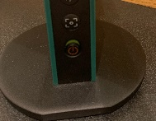
- You have to disconnect your laptop/source and then turn on the document camera. The document camera source will automatically go to the projector.
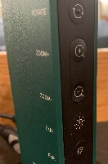
- Lift up the small red power switch near the document camera to turn it on and lift down to turn it off.
Zooming in and out
- Press the black buttons on the side of the document camera to zoom in and out.

Shut-down
- Press the power button on the bottom left side of the Crestron for 3 seconds to turn off.
If your content is not fully projected on the screen:
Windows: | Mac:
- Press the “Windows” Key + P.  - Choose Duplicate. | - Click on the Apple at the top of your computer screen.  - Click on Preferences.  - Click on Display.  - Click on Arrangements.  - Click on Mirror Display.

Microphone Audio
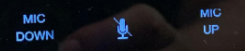
- Using the lapel microphone provided, turn on the unit and adjust the microphone volume by pressing and holding “MIC UP” or “MIC DOWN“. In between is the microphone mute button. These buttons are located right above the laptop/source audio controls.
- Extra batteries are provided.

Laptop/Source Audio
- Adjust the room speaker volume by pressing and holding the “+” and “-“ button. Touch and tap the speaker icon left of the “-“ icon to mute the laptop/source audio. These buttons will be located at the bottom of the Crestron.

Raising and Lowering Podium

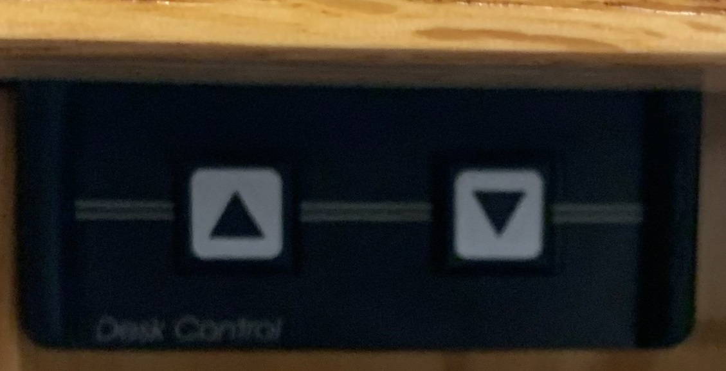
Located to your far left slightly underneath the front edge of the podium is a switch that allows you to raise or lower the podium. Press the up arrow to raise the podium. Press the down arrow to lower the podium.

Optional Equipment Available
For a list of available optional equipment, please visit:
https://www.engineering.cornell.edu/MTEI/mtei-equipment-check-out#no-back

