Contact Information
For AV support:
In Case of an AV Emergency Call: 607-255-0778
Email: Eng. Classtech Support engrclasstech@cornell.edu
AV Support Availability: Monday thru Friday, 8:00am to 5:00pm

For Facilities assistance:
Thom Quinn tlq3@cornell.edu 607-255-3540

For Emergencies Dial: 911 (CU Police) 255-1111

Room Equipment
Projector Projector Screen HDMI/USB-C Cable Connection Assisted Listening Microphones Podium (Height Adjustable)
Zoom Room

Connecting Your Device

Start-up
- Touch the Crestron touch panel to turn on.
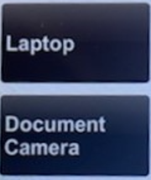
Connecting a Laptop
- Plug the proper video cable into your personal device (using HDMI or USB-C cable).

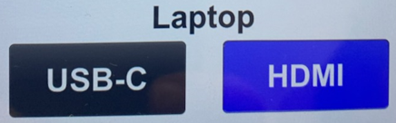
- Touch/tap the “Laptop” button and then touch/tap the cable you’re using to connect to the room. Then touch/tap the projector icon near the top of the Crestron to send your laptop’s display to the projector.

- Make sure your cable is completely seated all the way in your laptop.

Connecting the Document Camera
- Make sure the HDMI cable is completely seated all the way in the document camera.
- Touch/tap the “Document Camera” button. Then touch/tap the projector icon near the top of the Crestron to send the document camera display to the projector.

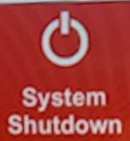
Shut Down
- Press the System Shutdown button located in the bottom left of the Crestron touch panel. This will shut down the room.

Audio

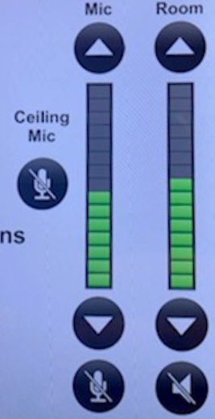
Room/Source Volume

Adjust the room speaker volume using the up and down arrows located under “Room” on the right side of the Crestron screen.

Microphone Volume:
Adjust the room microphone volume using the up and down arrows under “Mic” on the right side of the Crestron screen. Extra batteries for the microphone are on the podium or in the drawer in the AV rack under the podium.

Hearing assist headsets are in the side cabinet near the podium.

Raising and Lowering Podium

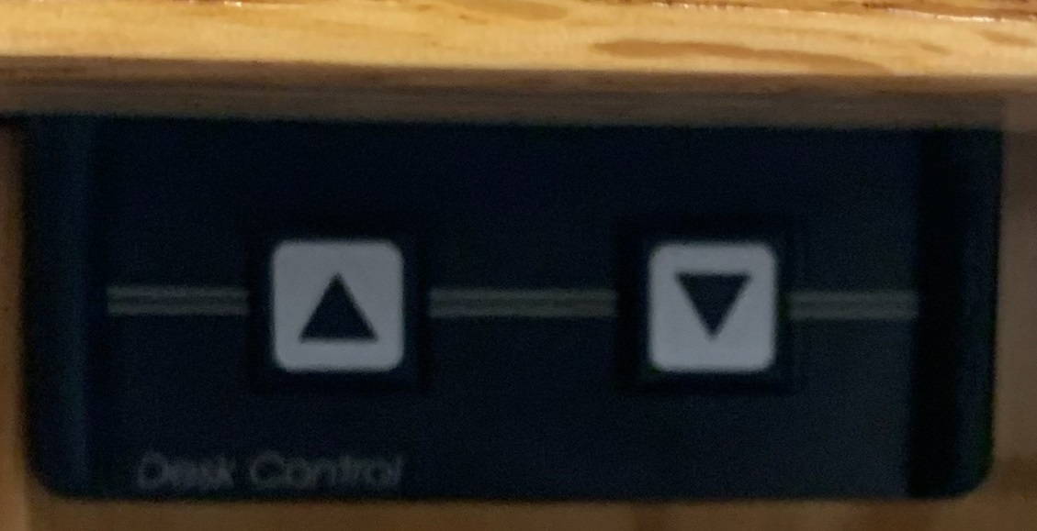
Located to your far left slightly underneath the front edge of the podium is a switch that allows you to raise or lower the podium. Press the up arrow to raise the podium. Press the down arrow to lower the podium.

Optional Equipment Available
For a list of available optional equipment, please visit:
https://www.engineering.cornell.edu/MTEI/mtei-equipment-check-out#no-back

Zoom Room Instructions from Wacom Tablet
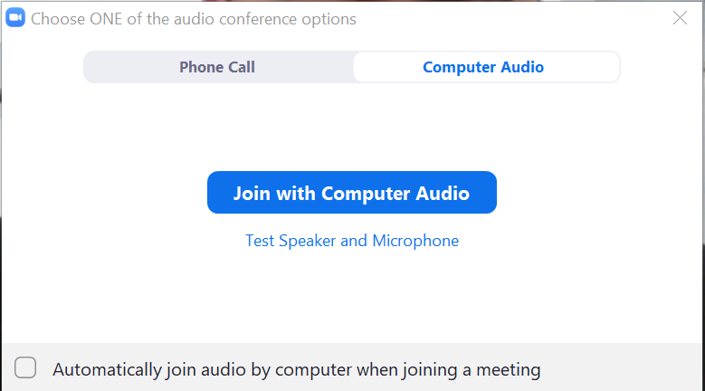
Joining the Room to your Zoom Meeting:
Create a Zoom meeting from your laptop. When prompted to “Join with Computer Audio”, click the “x” on the top right corner of the window. If you click “Join with Computer Audio”, there will be screeching audio feedback loop between your laptop and the room.

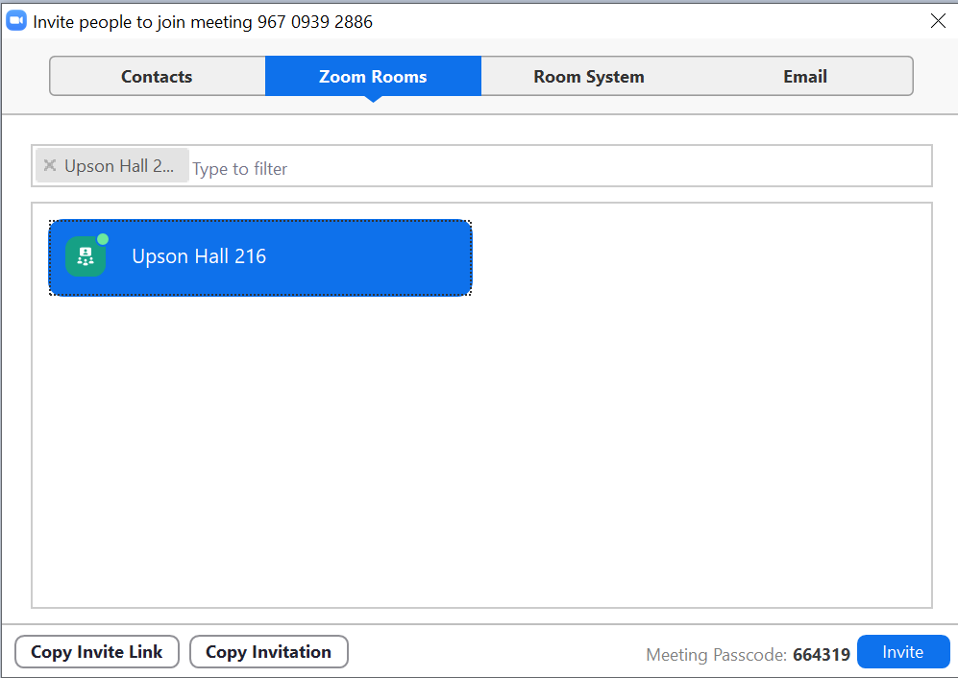
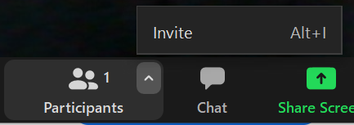
Along the Zoom options bar, to the right of “Participants”, click the up arrow and then click “Invite”. Click the “Zoom Rooms” tab, type your room in the search bar. Click the blue “Invite” button. The Wacom tablet will make a ringing noise and prompt a blue screen. Tap “Accept” on the Wacom tablet using the stylus provided.

To Enable Annotation for Shared Content in your Zoom Meetings (From CIT):
Log in to your Cornell Zoom account, click settings. Under In Meeting (Basic), scroll down to the Annotation option. Click the gray slider button to the right of Annotation to enable it. The slider will turn blue when enabled.

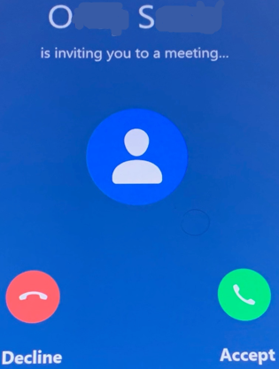
When Annotation is enabled, two additional options appear. They determine who can annotate a shared screen and whether meeting participants can save annotated screens:
- Allow saving of shared screens with annotations: To allow meeting participants to save annotated shared screens, click this checkbox, then click Save when asked to confirm.
- Only the user who is sharing can annotate: Do not select this option, as it will prevent the Zoom Room (which is a participant) from being able to make annotations.
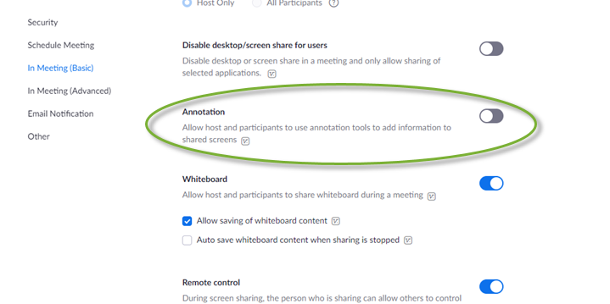
For more detailed information on Zoom annotation:
https://it.cornell.edu/zoom/zoom-rooms-annotate-shared-presentation

For more detailed information on Zoom Rooms: https://www.engineering.cornell.edu/MTEI/engineering-classroom-instructions/information-zoom-rooms

