Olin 255

Contact Information
For AV support:
In Case of an AV Emergency Call: 607-255-0778
Email: Eng. Classtech Support engrclasstech@cornell.edu
AV Support Availability: Monday thru Friday, 8:00am to 5:00pm

For Facilities support:
Thom Quinn tlq3@cornell.edu (607)255-3540

For Emergencies Dial: 911 CU Police: 607-255-1111

Room Equipment
Laptop connection (HDMI,VGA) Document Camera Room Speakers
Assisted Listening Wacom Tablet Room Microphone
Projector & Screen Chalkboards Video Adapter

Connecting Your Device
Start-up
- Touch the Crestron touch panel to turn on.
- Select desired source(s), either Laptop or Document Camera.
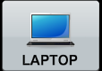
Connecting a Laptop
- To connect a laptop, plug the proper video cable into your personal device (using HDMI and any appropriate adapters).

Using the Document Camera
Document Camera
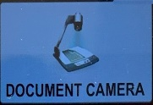
- Touch the Crestron touch panel to turn on.
- Select the DOCUMENT CAMERA option on the top bar of the touch panel and send it to the desired displays.
- Lift the arm of the document camera to turn it on.
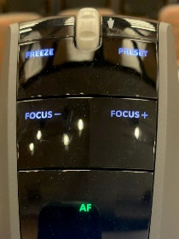
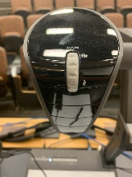
Zooming in and out
- Use the gray knob at the top of the document camera to zoom in and out
Auto Focus
- Press the green button labeled AF on the document camera to turn auto focus on and off

Shut-down
- Press the POWER OFF button located in the bottom left of the Crestron Touch panel. This will shut down the room.

Using the Wacom Tablet

To use the Wacom tablet in the room, please submit a ticket a week in advance to https://help.coecis.cornell.edu to schedule a training session.

If a problem occurs during a session, email https://help.coecis.cornell.edu and call 607-255-0778.

Audio

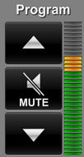
Program Audio
To adjust the room speaker volume, use the up and down Program arrows located on the right side of the Crestron.

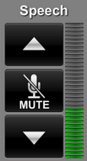
Speech
Using the lapel microphone provided (missing the mic), turn on the unit and adjust the microphone volume using the up and down Speech arrows located on the right side of the Crestron.
Extra batteries are provided.

