Phillips 101

Contact Information
For AV support:
In Case of an AV Emergency Call: 607-255-0778
Email: Eng. Classtech Support engrclasstech@cornell.edu
AV Support Availability: Monday thru Friday, 8:00am to 5:00pm

For Facilities support:
Patty Gonyea plg27@cornell.edu (607)592-9810

For Emergencies Dial: 911 CU Police: 607-255-1111

Room Equipment
Projector Wall Projector Screen Document Camera
Assisted Listening Lapel Microphones IClicker
Laptop Connection (HDMI, VGA, Mini DisplayPort) Confidence Monitor Wireless Presentation (Solstice Pod) Zoom Room

Start Up
- If the touch panel is dark, touch control panel.
- Select your source on the touch panel.
- For laptop, connect HDMI, VGA, Mini DisplayPort or Solstice Pod (Wireless Presentation).

Dual Display
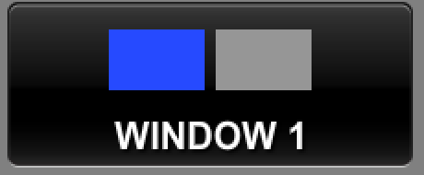
Click the “Video Windows” button
- Touch source for left screen, then touch Window 1.
- Touch source for right screen, then touch Window 2.
Changing dual display layout

Returns source to full screen. Click again returns dual image.

Displays the two sources side by side.

This button will swap the images to display in the opposite box.

Displays Windows 2 image inset in Windows 1 image. Pressing this button multiple times will move the small image to other corners on the screen.

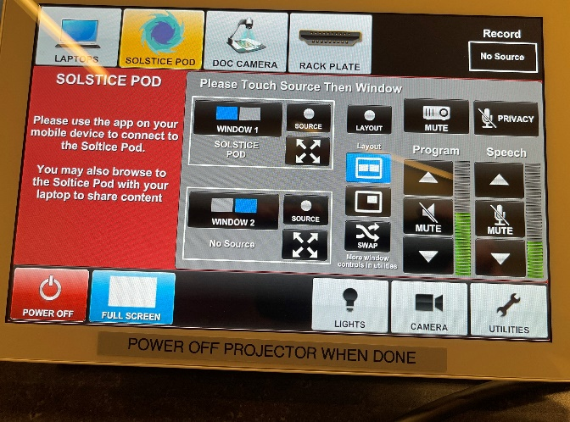
**Control panel recording buttons temporarily disabled due to COVID**

The privacy button will mute the lavalier mic and handheld mic from the recording. WARNING: The Chat 170 mic still records.

More Layout Options Available via Utilities

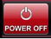
Powering Down Projector
Power off using the Crestron touch panel.

Audio

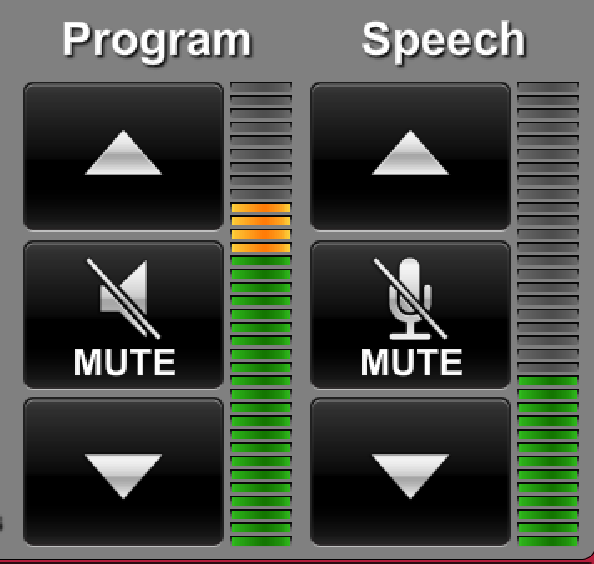
Program Audio
To adjust the room speaker volume, use the up and down Program arrows located on the right side of the Crestron.

Speech
Using the lapel microphone provided, turn on the unit and adjust the microphone volume using the up and down Speech arrows located on the right side of the Crestron.

Zoom Room Instructions from Wacom Tablet

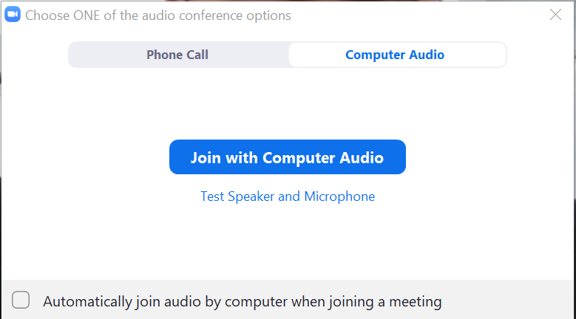
Joining the Room to your Zoom Meeting:
Create a Zoom meeting from your laptop. When prompted to “Join with Computer Audio”, click the “x” on the top right corner of the window. If you click “Join with Computer Audio”, there will be screeching audio feedback loop between your laptop and the room.

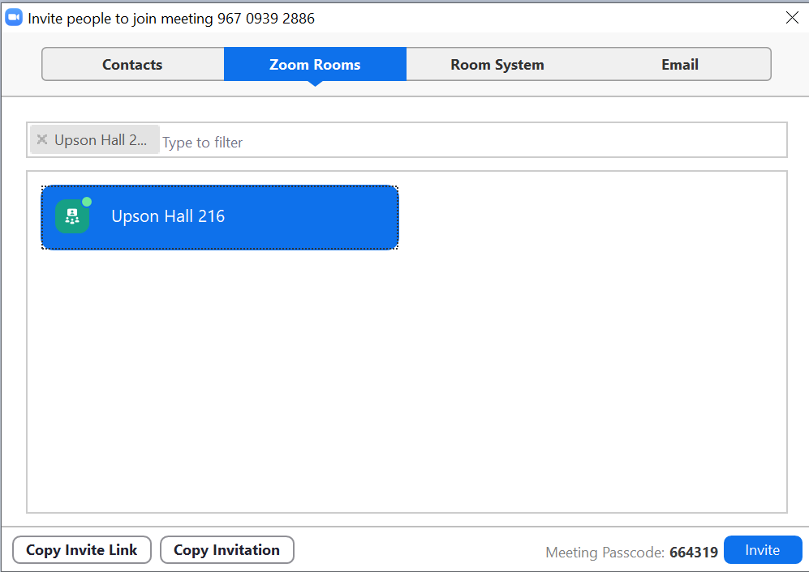
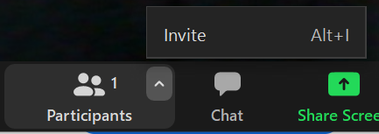
Along the Zoom options bar, to the right of “Participants”, click the up arrow and then click “Invite”. Click the “Zoom Rooms” tab, type your room in the search bar. Click the blue “Invite” button. The Wacom tablet will make a ringing noise and prompt a blue screen. Tap “Accept” on the Wacom tablet using the stylus provided.

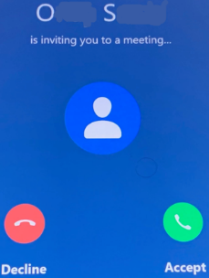

To Enable Annotation for Shared Content in your Zoom Meetings (From CIT):
Log in to your Cornell Zoom account, click settings. Under In Meeting (Basic), scroll down to the Annotation option. Click the gray slider button to the right of Annotation to enable it. The slider will turn blue when enabled.

When Annotation is enabled, two additional options appear. They determine who can annotate a shared screen and whether meeting participants can save annotated screens:
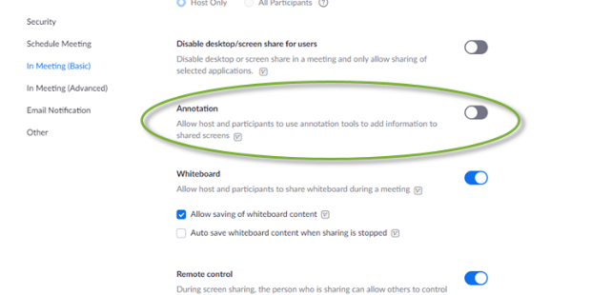
- Allow saving of shared screens with annotations: To allow meeting participants to save annotated shared screens, click this checkbox, then click Save when asked to confirm.
- Only the user who is sharing can annotate: Do not select this option, as it will prevent the Zoom Room (which is a participant) from being able to make annotations.

For more detailed information on Zoom annotation:
https://it.cornell.edu/zoom/zoom-rooms-annotate-shared-presentation

For more detailed information on Zoom Rooms: https://www.engineering.cornell.edu/MTEI/engineering-classroom-instructions/information-zoom-rooms

