Contact Information
For AV support:
In Case of an AV Emergency Call: 607-255-0778
Email: Eng. Classtech Support engrclasstech@cornell.edu
AV Support Availability: Monday thru Friday, 8:00am to 5:00pm

For Facilities support:
Patty Gonyea plg27@cornell.edu (607)255-8588

For Emergencies Dial: 911 CU Police: 607-255-1111

Room Equipment
Projector & Screen HDMI Connection VGA Connection
Speakers Portable Microphones Assisted Listening

Basic Presentation
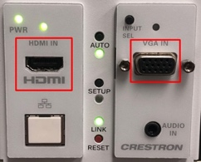
- Connect to your laptop using either HDMI or VGA. Ensure that the cable is plugged into your laptop as well as the wall plate.
- Turn projector on using Sony remote power button. Use the same button to shut the room down when finished.

Room Audio
- Using HDMI
  - Ensure that laptop is properly connected to and displaying.
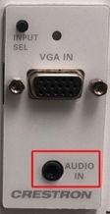
  - Check where your audio is routed to. Your audio should be going to HDMI-Crestron.
- Using VGA
  - Plug in AUX cable to headphone jack on your laptop
  - Ensure that the AUX cable is also plugged into the ‘Audio In’ plug on the wall plate.
  - Check where your audio is routed to. Your audio should be going to Headphones.
- Adjusting audio levels
  - Using the Volume knob above the wall plate to adjust the volume in the room.

If your content is not fully projected on the screen:
Windows: | Mac:
- Press the “Windows” Key + P.  - Choose Duplicate. | - Click on the Apple at the top of your computer screen.  - Click on Preferences.  - Click on Display.  - Click on Arrangements.  - Click on Mirror Display.

Optional Equipment Available
For a list of available optional equipment, please visit:

https://www.engineering.cornell.edu/MTEI/mtei-equipment-check-out#no-back

