Contact Information
For AV support:
In Case of an AV Emergency Call: 607-255-0778
Email: Eng. Classtech Support engrclasstech@cornell.edu
AV Support Availability: Monday thru Friday, 8:00am to 5:00pm

For Facilities support:
Patty Gonyea plg27@cornell.edu (607)592-9810

For Emergencies Dial: 911 CU Police: 607-255-1111

Room Control
Projector Projector Screen HMDI Connection VGA/HDMI Adapter

Connect your Device
Start-up
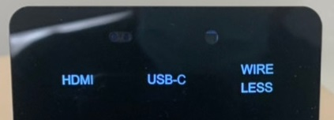
- Touch the Crestron touch panel to wake up.
Connecting a Laptop
- Plug the proper video cable into your personal device (using HDMI or USB-C cable).

- Touch/tap the icon for the correct cable you’re using. The icon will go from white to blue when selected. This will send your laptop’s display to the projector.

- Make sure your cable is completely seated all the way in your laptop.
Shut-down
- Press the power button located in the bottom right of the Crestron Touch panel. This will shut down the projector.

If your content is not fully projected on the screen:
Windows: | Mac:
- Press the “Windows” Key + P.  - Choose Duplicate. | - Click on the Apple at the top of your computer screen.  - Click on Preferences.  - Click on Display.  - Click on Arrangements.  - Click on Mirror Display.

Wireless Presentation

Tap/touch “WIRELESS” on the Crestron and follow the prompted instructions on the projector screen. Set up should take no longer than one minute.

Audio

Microphone Audio
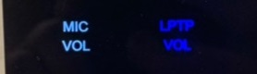
- Touch/tap “MIC VOL”. The volume source will go from white to blue when selected.
- Using the lapel microphone provided, turn on the unit and adjust the microphone volume by pressing and holding the “+” and “-“ icons.
- Touch/tap the speaker icon left of the “-“ icon to mute your selected source (MIC or LPTP) audio.
- Extra batteries are provided.

Laptop/Source Audio
- Touch/tap “LPTP VOL”. The volume source will go from white to blue when selected.
- Adjust the room speaker volume by pressing and holding the “+” and “-“ icons.
- Touch/tap the speaker icon left of the “-“ icon to mute your selected source (MIC or LPTP) audio.

Optional Equipment Available
For a list of available optional equipment, please visit:

https://www.engineering.cornell.edu/MTEI/mtei-equipment-check-out#no-back

