How to Self-Enroll in ENG Advising Fall 2018

Go to the Blackboard login page. Click Cornell NetID. https://blackboard.cornell.edu/webapps/login/

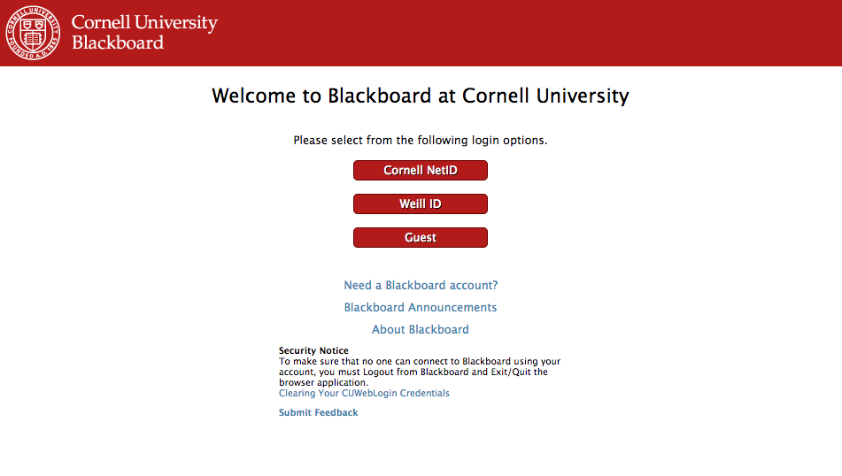
Sign in with your NetID and password.
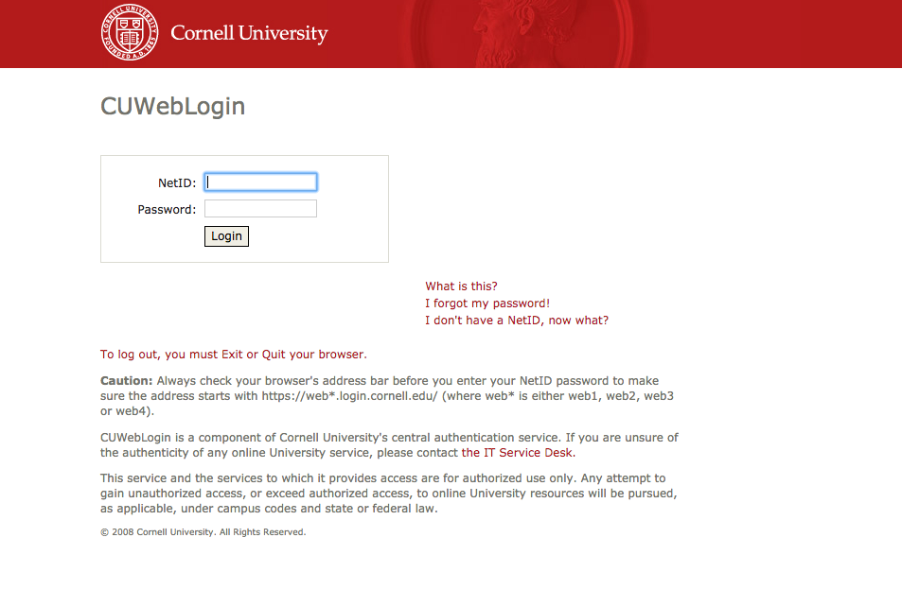

Click on Course Search at the top left of the page.
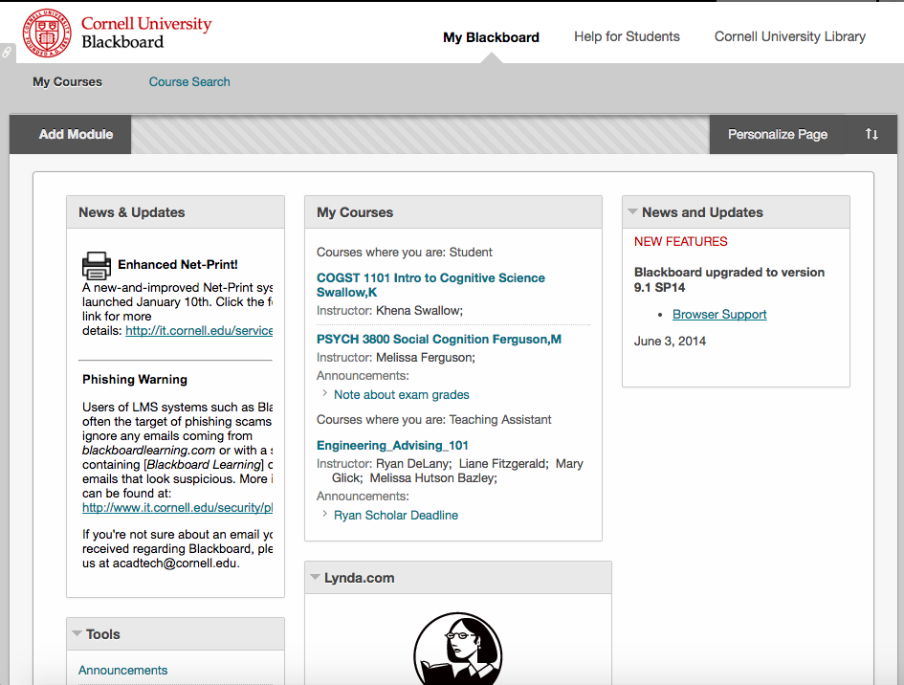

Click on Engineering.
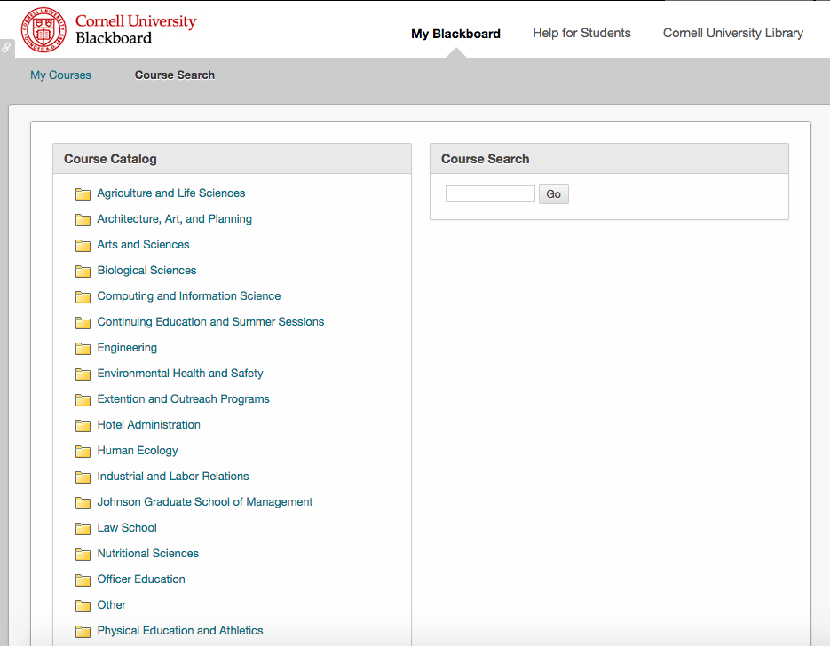
Scroll down to the bottom of the page to hover over engadvising101.
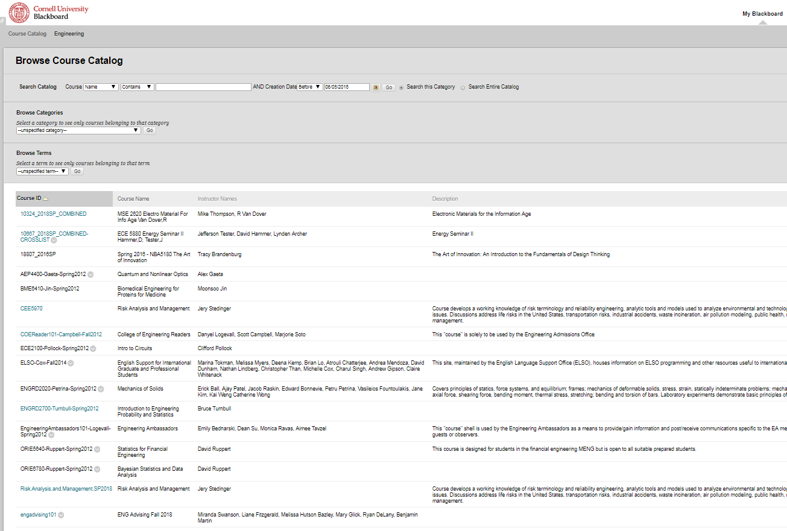

Click the arrow and click Enroll.
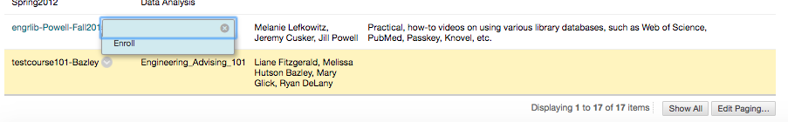

Click Submit on this page.
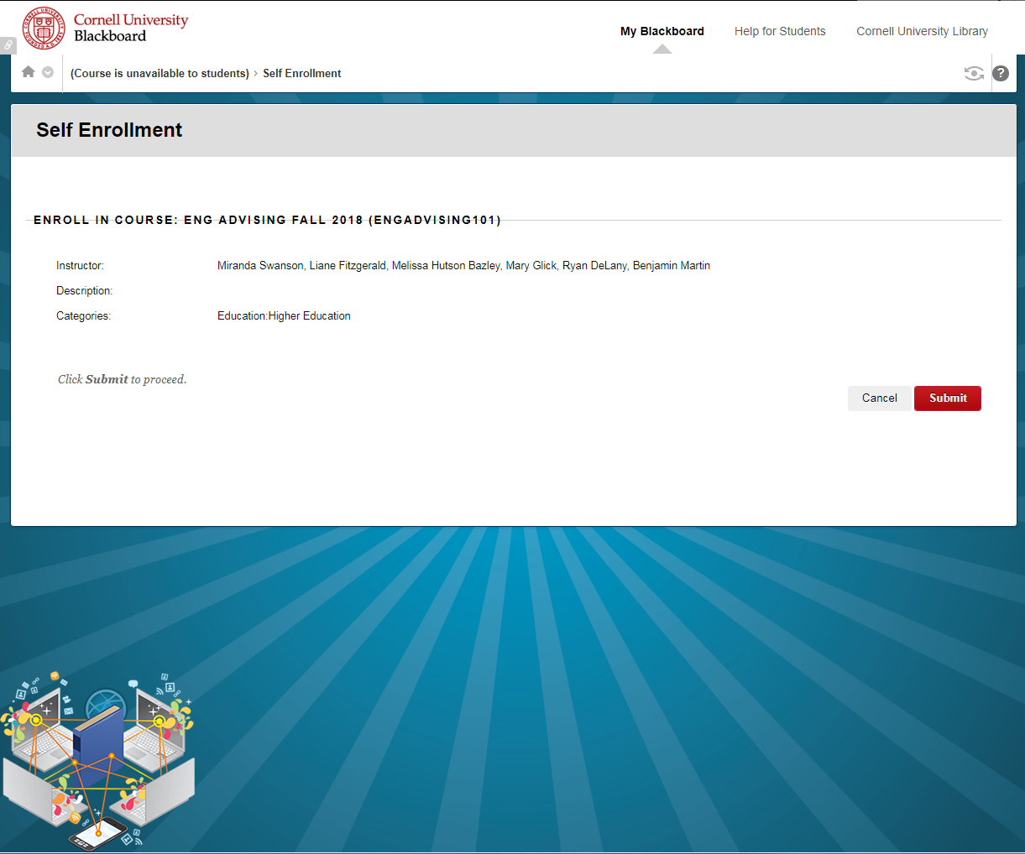
Click OK.
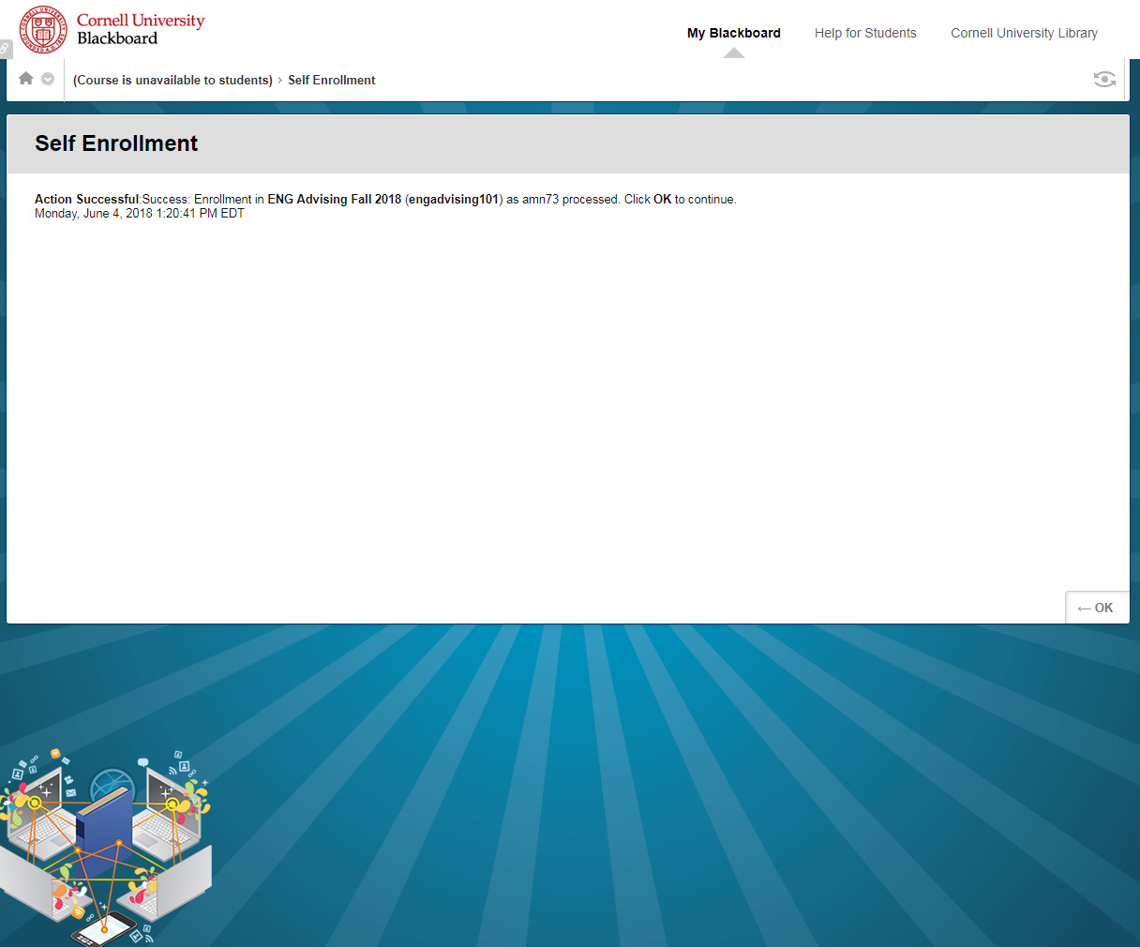
You should end up on this page. Happy exploring!
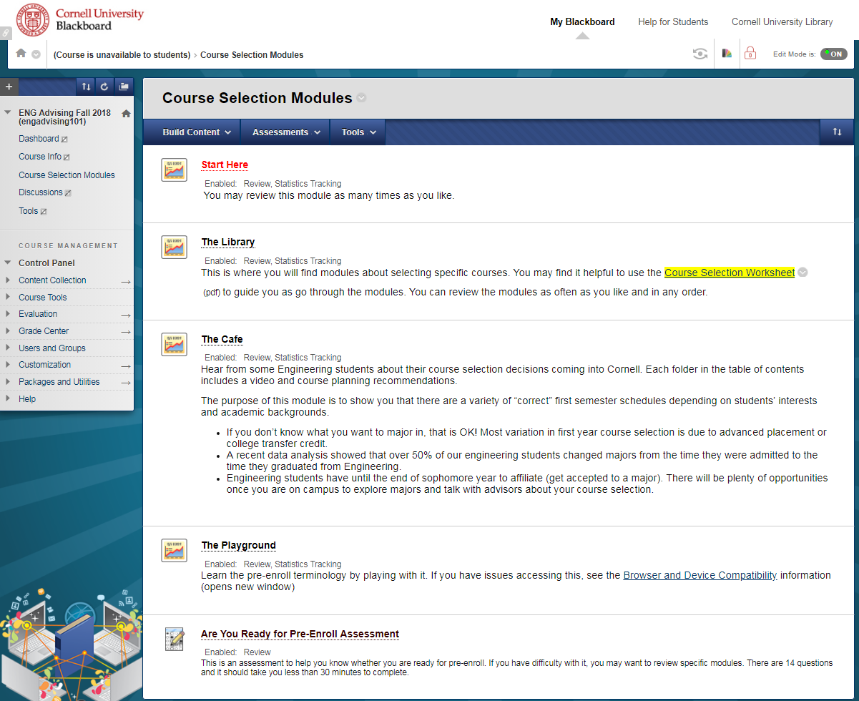

Be Aware: Different internet browsers affect the presentation of the content.
- View the content on a desk top or laptop computer.
- Disable your pop up blockers.
- Use Internet Explorer (IE) version higher than 9, if you use IE.
- If you use Chrome, you will need to disable your popup blocker. If you get an error message, tell it to ignore the error, and then it should work.
- If you use Safari, make sure Flash is enabled.
- After you watch a module and click to review it, a dialogue box will appear called “Review Attempt History.” Click “Start New Submission” to watch it again.

